Softwares download :

Eclipse : http://www.eclipse.org/downloads/packages/eclipse-ide-java-ee-developers/mars2 (In that link, download the software for Windows 64bit version)

Postgresql database : https://www.postgresql.org/download/windows/ (Download 9.5 version database)

Apache Tomcat server : http://www-us.apache.org/dist/tomcat/
After going to the above link, download the apache tomcat server from the “/tomcat-8/v8.x.xx/bin/”
(Download apache-tomcat-8.x.xx.zip)

Java JDK 1.8 : http://www.oracle.com/technetwork/java/javase/downloads/jdk8-downloads-2133151.html (download the Java SE Development Kit 8u111 version)

Maven Build Tool : http://www-eu.apache.org/dist/maven/maven-3/3.3.9/binaries/apache-maven-3.3.9-bin.zip

Steps for basic Setup on your machine

- Create a new folder named “SmartSchoolProject”
- Now under “SmartSchoolProject”, create 3 new folders named “SmartSchoolProject-GIT”, “SmartSchoolProject-Coding” and “SmartSchoolProject-Software”.
- Copy Eclipse, postgresql database, Apache Tomcat Server, Maven installation files onto “SmartSchoolProject-Software” folder.
- Download latest java jdk from Oracle downloads.
- Install jdk on your environment.
- Now install eclipse on your machine and point the workspace of the eclipse to the “SmartSchoolProject-Coding” (which we created above in step-2).
- Now install postgresql database on your machine. (give the database password as 'postgres')

Steps for Maven Setup :

Follow the steps defined on web page : http://www.mkyong.com/maven/how-to-install-maven-in-windows/

1. Make sure JDK is installed, and “JAVA_HOME” variable is added as Windows environment variable.
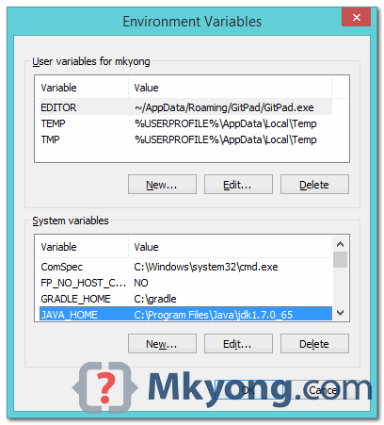

2. Visit Maven official website (http://maven.apache.org/download.cgi), download the Maven zip file, for example : apache-maven-3.2.2-bin.zip. Unzip it to the folder you want to install Maven.
Assume you unzip to this folder – C:\Program Files\Apache\maven

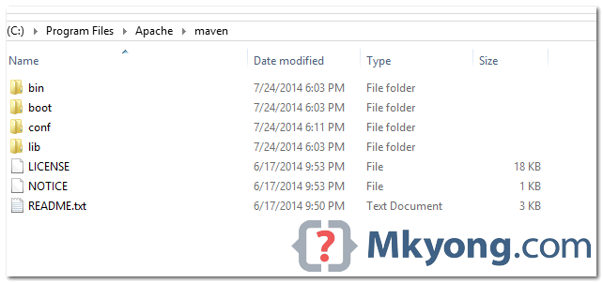

3. Add both M2_HOME and MAVEN_HOME variables in the Windows environment, and point it to your Maven folder.

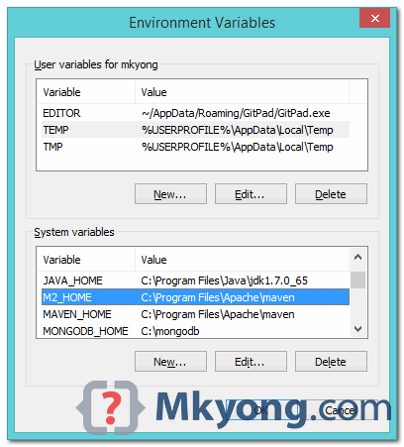

4. Update PATH variable, append Maven bin folder – %M2_HOME%\bin, so that you can run the Maven’s command everywhere.

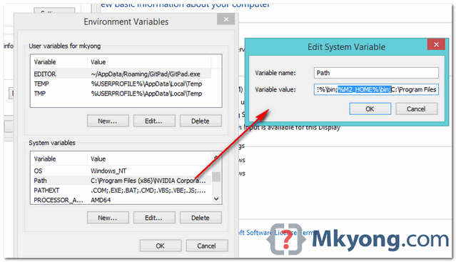

5. Now Maven setup is Done. to verify it, run mvn –version in the command prompt.

For example:

C:\Users\mkyong>mvn -version
Apache Maven 3.2.2 (45f7c06d68e745d05611f7fd14efb6594181933e; 2014-06-17T21:51:42+08:00)
Maven home: C:\Program Files\Apache\maven
Java version: 1.7.0_65, vendor: Oracle Corporation
Java home: C:\Program Files\Java\jdk1.7.0_65\jre
Default locale: en_US, platform encoding: Cp1252
OS name: "windows 8.1", version: "6.3", arch: "amd64", family: "windows"
C:\Users\mkyong>

If you are seeing the maven version correctly, then it means that the Maven setup is successful.

Setup for GIT Repository in Eclipse:

  - Follow the below screenshots for importing GIT projects into Eclipse :

Click on “GIT Repositories” under “Git” section.
Click on “Clone a Git repository”.

In the Authentication section, enter your GIT account credentials to login to GIT. I have given access for the above GIT project workspace (accessed by the .git URL).

Note : Make sure you select the correct GIT branch designated to you. Changes should be done only on that branch. No other branches should be modified.

In the directory, give the “SmartSchoolProject-GIT” folder path , which was created during the initial steps of folders creation.

After giving the correct path, right of “Git Repositories” section in the bottom of eclipse and then click on “Import Projects”.

Keep the default values.
Select both the projects as shown in the above screenshot.

And that’s it. Projects are imported into your workspace from GIT. Any change you do in your code can be easily merged into GIT repository directly from eclipse..

Setting up Apache Tomcat Server in eclipse :

Now you should already have Apache Tomcat zip file downloaded on your system.

Unzip that file as a folder.

Open eclipse and follow the below screenshots :-

Handling issues during initial project startup on tomcat server :

Issue#1 : First you need to run both the projects as “Run As → Maven Clean”, then do a project clean (Project--> clean) and then “Run As → Maven Install”. First do it for the service project and then at the last do for the web project.

Make sure that both the maven install is success.

-----------------------------------------------------------------------------------------------------------------
Issue#2 : While doing Maven clean/install, if you face the below issue :

[ERROR] No compiler is provided in this environment. Perhaps you are running on a JRE rather than a JDK?

Then it means that we are using JRE, not JDK.. For fixing that, please follow below steps :

Go to Window → Preferences → Java → Installed JREs.
And see if there is an entry pointing to your JDK path, and if not, click on Edit button and put the path you configured your JAVA_HOME environment

See below screenshot for example :

Issue#3 : While running Maven install, if you see Build Failure with the below error message :
multi-catch statement is not supported in -source 1.5 (use -source 7 or higher to enable multi-catch statement)

Then do the below steps to fix it.

- Do maven clean. (Run As Maven Clean)
- Do project clean. (Project--> clean).
- Maven install. (Run As Maven Install)
- If you see the above error message again with build failure, then clean the project from eclipse (Project--> clean).
- Once it is cleaned, DON’T do maven clean again. Just run Maven Install again. That should work fine.

-----------------------------------------------------------------------------------------------------
Issue#4 : When you run the project for the first time on tomcat and if you got an error that is saying that the java files on the dependent project (say, java files in “SmartSchoolService” project) are not accessible or got NoClassDefFound error for the dependent project class files, then it means that even though you add the dependent project to the web project library as dependency, the tomcat server doesn't know that.

So you need to do the follow setup on tomcat configuration so that dependent project jar is picked.
(copied from : http://stackoverflow.com/questions/5603758/tomcat-throws-classnotfound-exceptions-for-classes-in-other-open-eclipse-project)

What you need to do is this:
- In Eclipse go to Window > Show View > Servers > and a new tab called “Servers” in the bottom or main region.
- In Servers, double click the server you want
- This action should open a window called “Overview”, with your selected Server in the TAB
- In this window select: Open launch configuration, and click the link.
- In the Edit Configuration window, select the tab called Classpath
- In the ClassPath textbox, select the line: User Entries
- Now click the button on the right entitled: Add Projects
- In the resulting Project Selection window, select the “SmartSchoolService” project.
Note : When you add the “SmartSchoolService” project, make sure you delete the automatically added unwanted entry “org.eclipse.m2e.MAVEN2_CLASSPATH_CONTAINER”

- Close these windows by clicking Apply then OK as appropriate as you work up the stack
- Restart your server in the Overview window

See below screenshot and make sure you have the configuration exactly same as in the screenshot.

